
Name: Hariharan E (192421337)
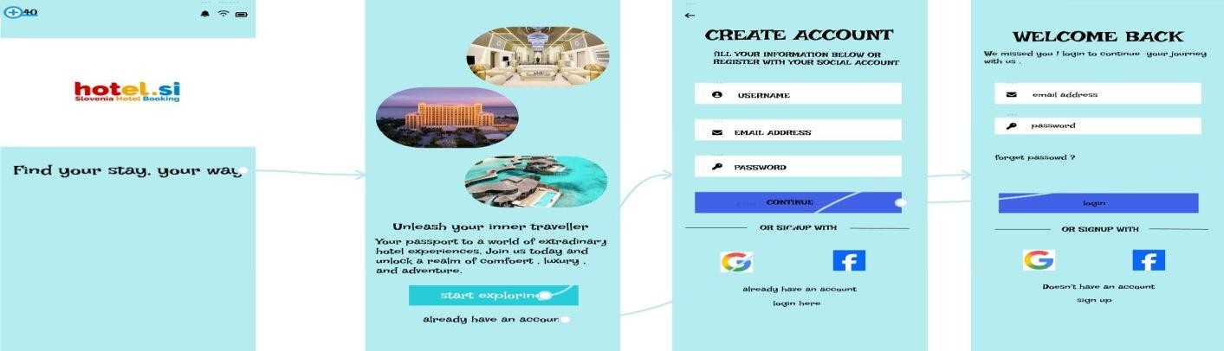
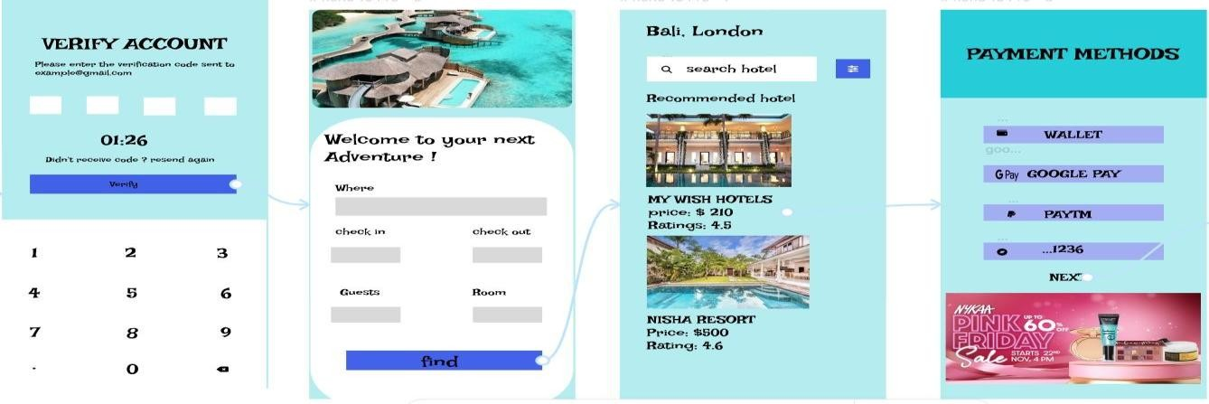



HOTEL BOOKING
S
YSTEM

